# **What prompts me to say this?**

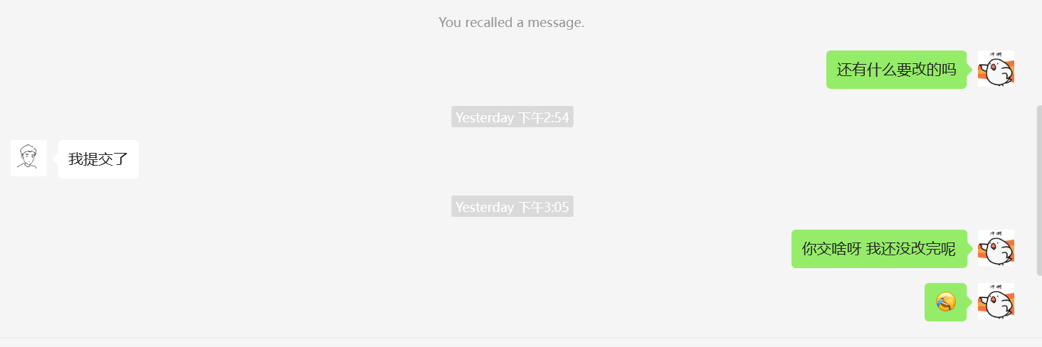

🐤：Is there anything else that needs to be revised?

👤：I submitted it.  
🐤：Why did you submit it? I haven’t finished revising it yet.  
🐤：😭

The issue started when Yang Yang submitted the group assignment without my consent while I was still working on revisions. When I later asked him about it, he said, "I mentioned earlier that I would submit a version on the 8th," which sounded more like an excuse. It seemed he was trying to claim more contribution or credit. Afterwards, I told him I had made further changes and asked him to resubmit a new version that aligns with the Git repository, but he stopped responding.

# **"Git Commit Record"**

You may wish to take a look at the Git repository, where the vast majority of commits were made by Siyuan Chen, especially during the early stages (before Mar 10, 2025

) of the project.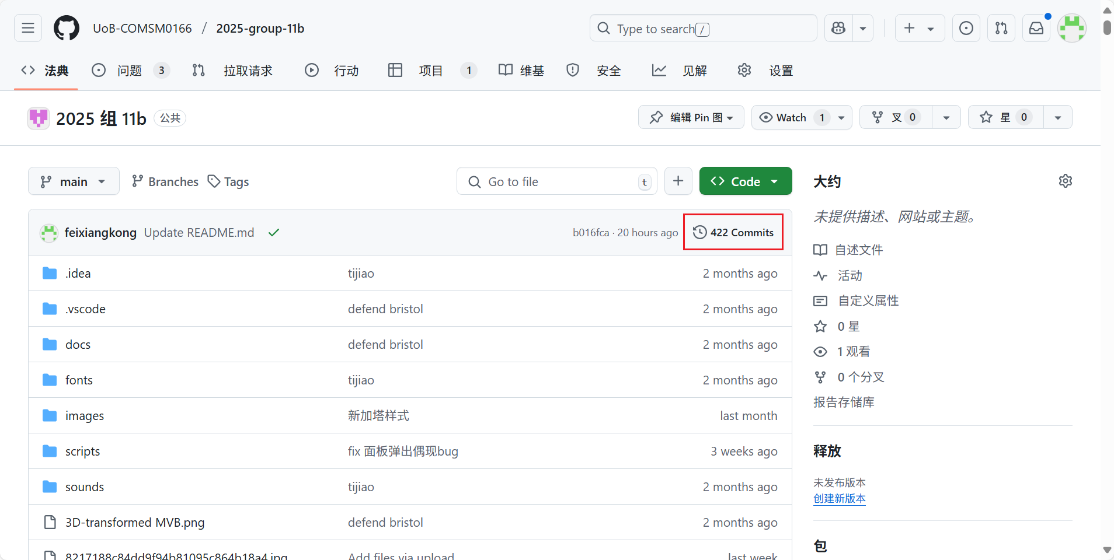

# **About the report**

The report (introductions & requirements & implementation & most part of evaluation & most part of process & sustainability & conclusion) part was finished by Siyuan Chen (which you could see the commit record)

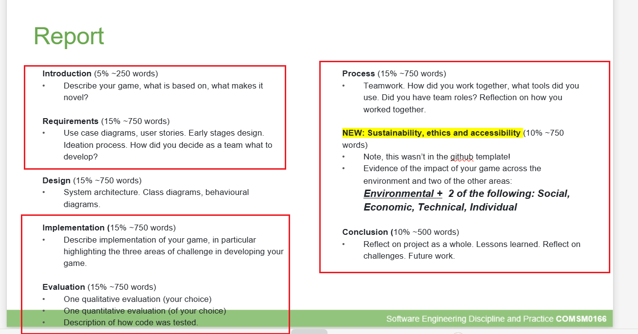

The report (design part & part of evalution & part of process) was finished by Yang Yang

# **About the video**

The video was totally finished by Siyuan Chen, here is the link : <https://youtu.be/Re5hUP_9Xms>

# **About the game demo**

As early as April 1st, 2025, I had completed the development of the game, including almost all of the code, collected assets, and creative concepts. I shared a demo video with him at that time, hoping he could contribute new features such as difficulty settings and sustainability improvements. However, the game has remained virtually unchanged since the version I originally sent him. Here is the early game Link : <https://youtu.be/apVPTRhCMVY>

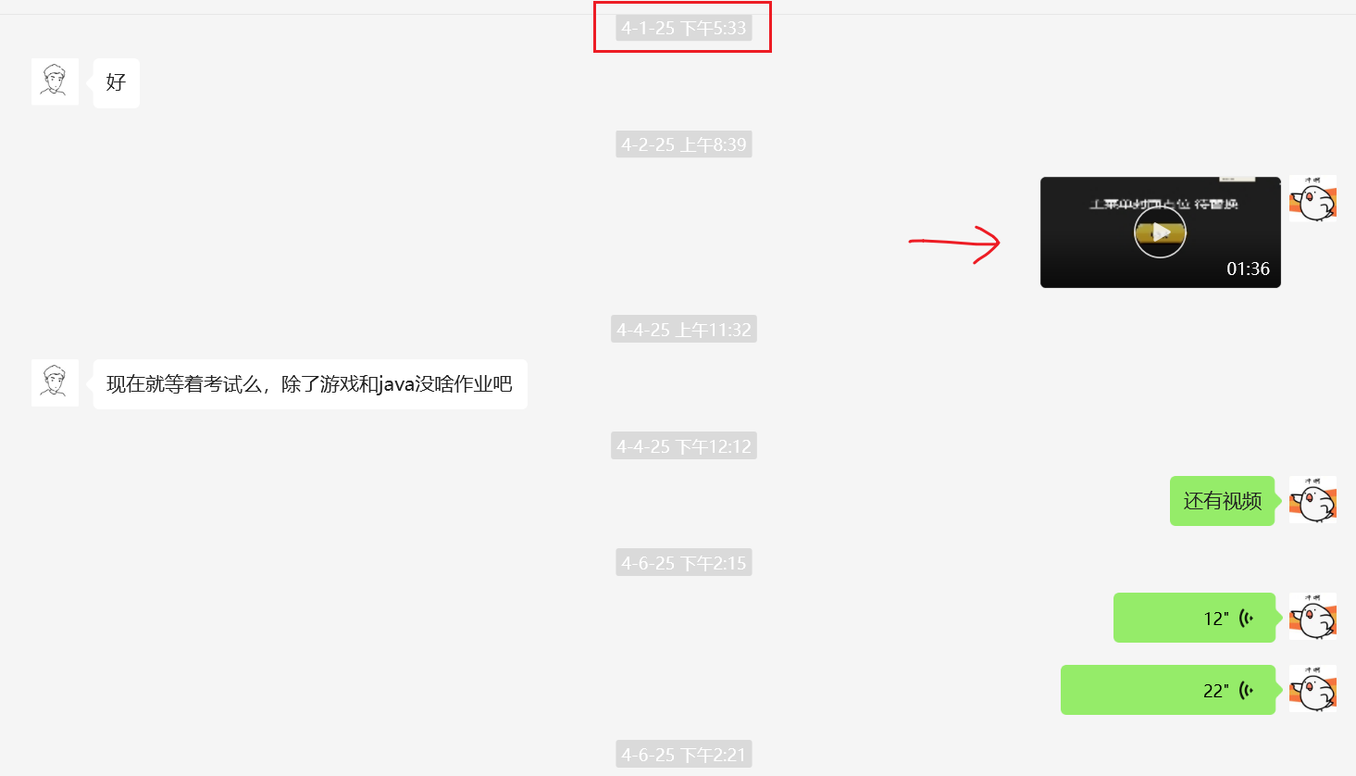

👤: Okay.  
👤: Now we’re just waiting for exams. Apart from the game and the Java assignment, there’s probably nothing else left.

🐤: (Video sent – 01:36)  
🐤: There’s also a video.  
🐤: (Voice message – 12 seconds)  
🐤: (Voice message – 22 seconds)

One day after that, he suddenly claimed that he had fixed a bug in my code, saying that towers couldn't be placed (with a confused look). I then sent him a video I had previously recorded showing that it worked, but he went silent again. This made me seriously doubt whether he had simply used GPT or something similar to rewrite my code, or whether the bug he mentioned never existed in the first place.

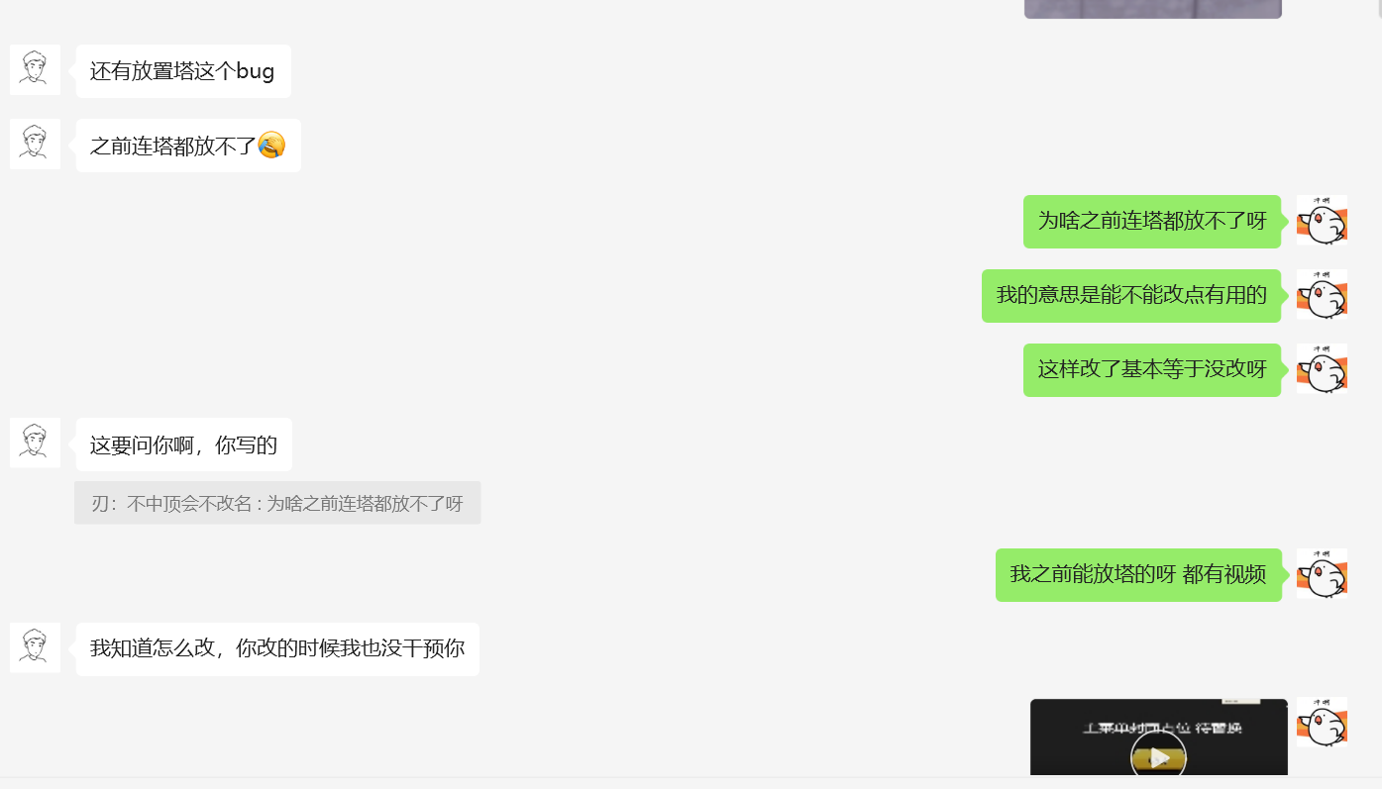

👤：There’s also a bug when placing towers.  
👤：Previously you couldn’t even place a tower. 😭  
🐤：Why couldn’t you place towers before?  
🐤：I meant, could you at least make some useful changes?  
🐤：What you changed is basically like not changing anything.  
🐤：I could place towers before. I even have a video.  
👤：You have to ask yourself, you wrote it.  
👤：I know how to fix it. You didn’t consult me when you made the changes.

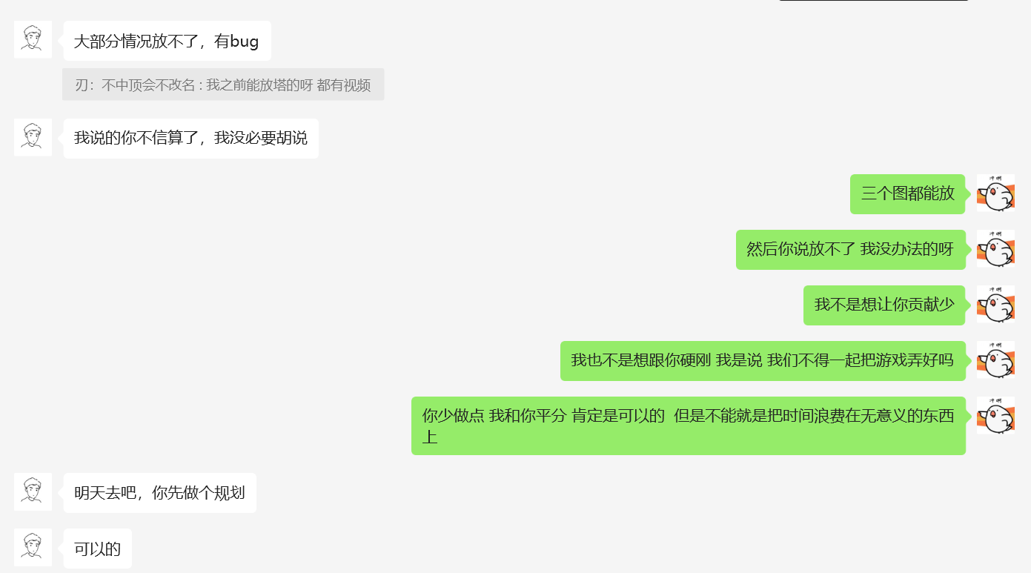

👤：In most cases, the towers can’t be placed — there’s a bug.  
🐤（引用）：I could place them before. I even have a video.  
👤：If you don’t believe what I said, forget it then. I have no reason to lie.

🐤：All three towers could be placed.  
🐤：Then you said they couldn’t be placed, so what could I do?  
🐤：I’m not trying to minimize your contribution.  
🐤：I’m not trying to argue with you. I’m saying, can’t we just work together to make the game better?  
🐤：If you do a bit less and I share the work with you, that’s absolutely fine. But we can’t afford to waste time on meaningless things.

👤：Let’s go tomorrow. You make a plan first.  
👤：Sounds good.

# **After that, he suddenly proposed splitting the contribution equally.**

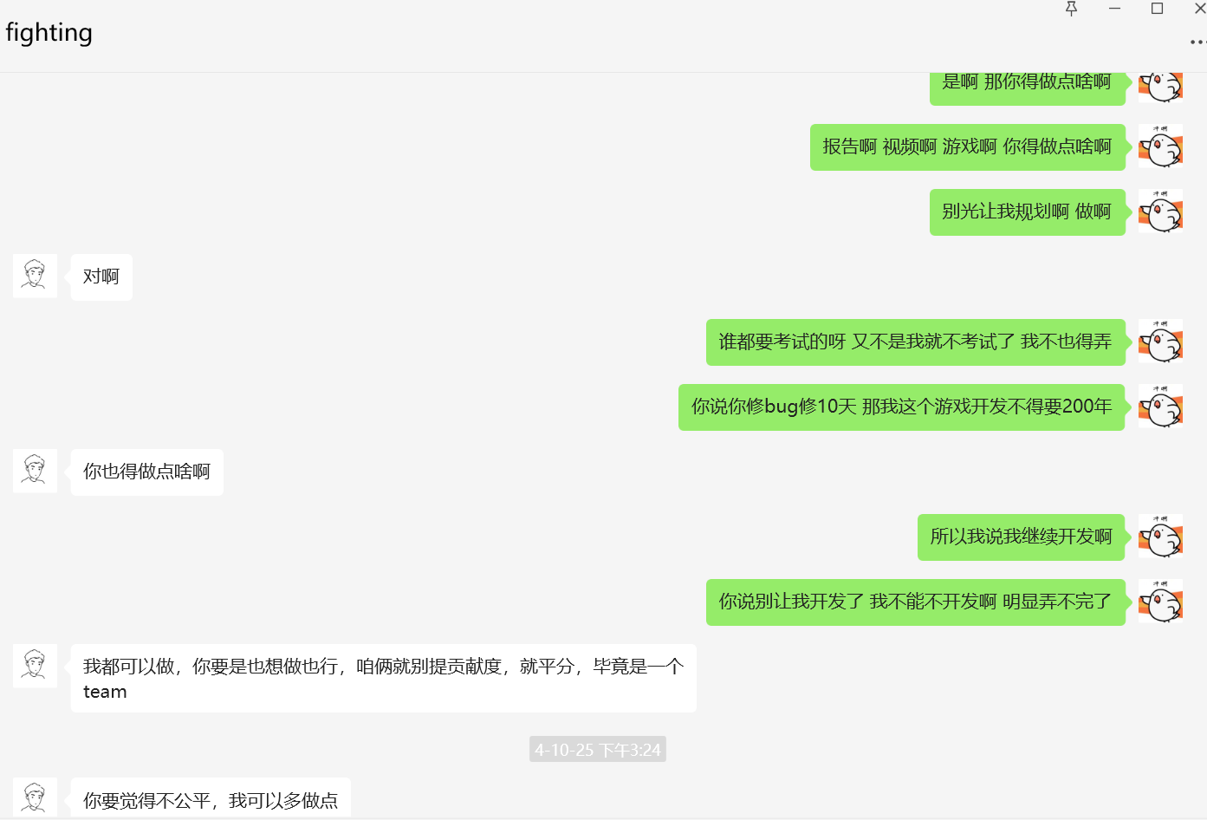

🐤：Exactly, then you really need to contribute something.  
🐤：There’s the report, the video, the game — you’ve got to do something.  
🐤：Don’t just leave everything to me to plan. Do something.  
🐤：Who doesn’t have exams? It’s not like I’m skipping mine. I have to deal with it too.  
🐤：You said fixing bugs would take 10 days — then what, I’d need 200 years to finish this game?  
🐤：That’s why I said I’ll just keep going with development.  
🐤：You told me not to start developing. I can’t just not work on it. Obviously, it won’t get done.

👤：Yeah.  
👤：You need to do something too.  
👤：I’m fine with doing the work. If you want to do it too, that’s fine.  
👤：But then let’s not talk about who contributed more, we split the contribution equally. After all, we’re one team. ← **(this is the part where he suddenly proposes equal contribution)**  
👤：If you think it’s unfair, I can do a bit more.

Then he suddenly claimed that I had rolled back his code, although I honestly have no idea what functionality his code was supposed to implement.

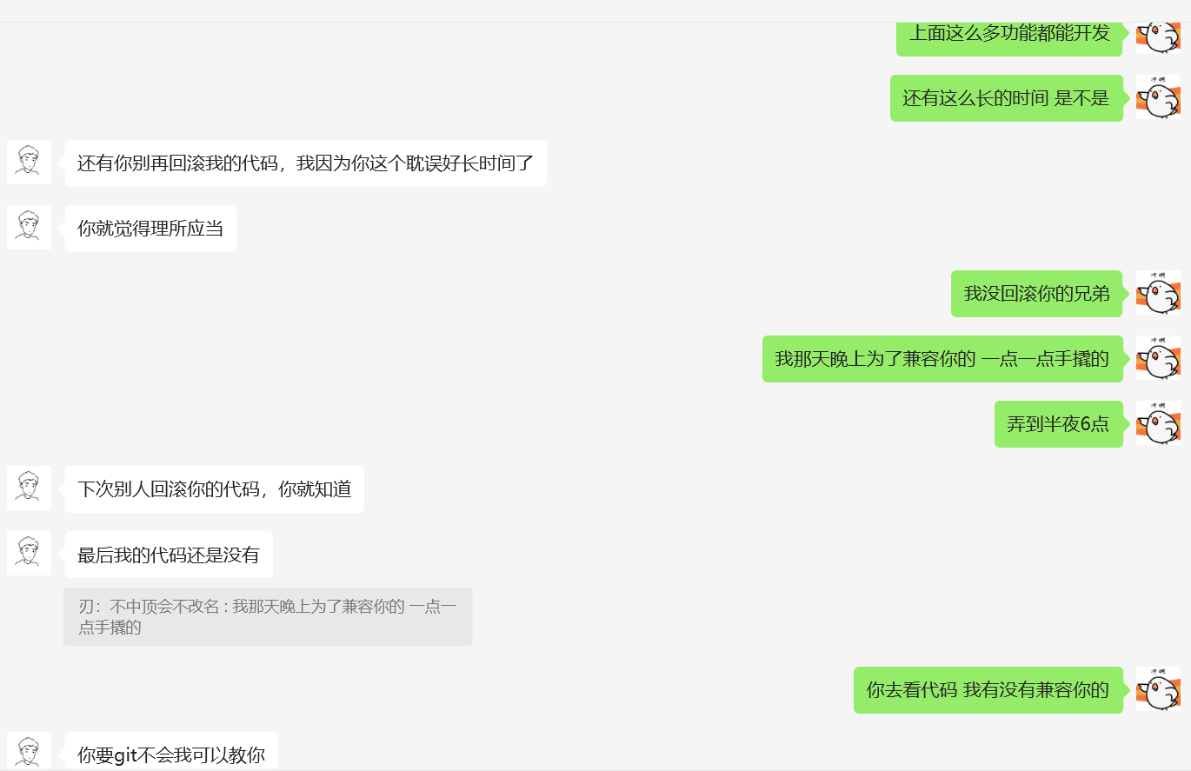

👤：Also, don’t overwrite my code again. I lost a lot of time that night because of you.  
👤：And you acted like it was completely reasonable.  
🐤：Look at all the features I managed to develop.  
🐤：And you think I had that much extra time? Really?  
🐤：I didn’t overwrite your code, man.  
🐤：That night I stayed up and tried to adjust everything carefully to fit your version.  
🐤：I worked until six thirty in the morning.

👤：Next time someone overwrites your code, you’ll understand.  
👤：In the end, my code still didn’t get included.  
👤：If you don’t know how to use Git, I can teach you.  
🐤：Go check the code. See for yourself whether I tried to accommodate your changes or not.

# **Conclusion**

I cannot deny that Yang Yang made significant contributions at the beginning of the project, including coming up with the initial concept and providing the inspiration. However, during the middle and later stages, he was almost completely absent, or was involved only in fixing some mysterious bugs, or claiming that I had rolled back his code. Of course, this is just my personal perspective. Therefore, I have submitted a recently updated version of the Git repository along with the report, and included my own view on the contribution breakdown, for reference only.

# **Appendix**

If you would like to verify what I said, you can roll back the Git repository to the version from April 6th, 2025. The game at that point is almost identical to the current version.

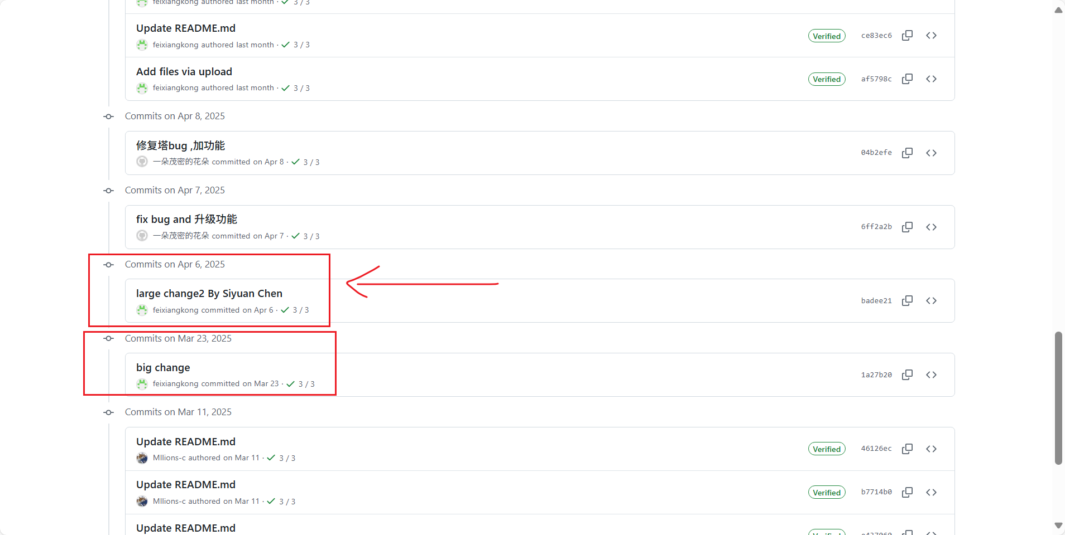

In addition, all the game maps, missions, cover art, and characters were drawn by me, and I still have all the original assets. ( You can check on Git to see who uploaded the images.)

For example:

